Compilation error: Reason for these errors can be in some of the import statements in classes have import references of another classes which does not exists in master package. For example, look at the following error.

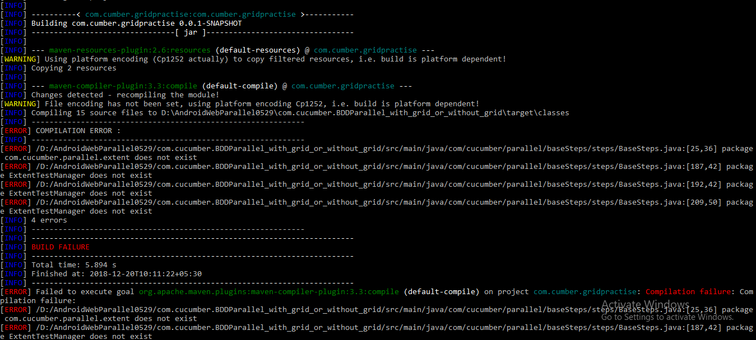

Here, in the base steps class there are import statements for ‘ExtentTestManager’ class which was residing in another master e.g. src/test/java where as BaseSteps class was residing in src/main/java. So moving the ExtentTestManager class inside the src/main/java from src/test/java has resolved these issues.

